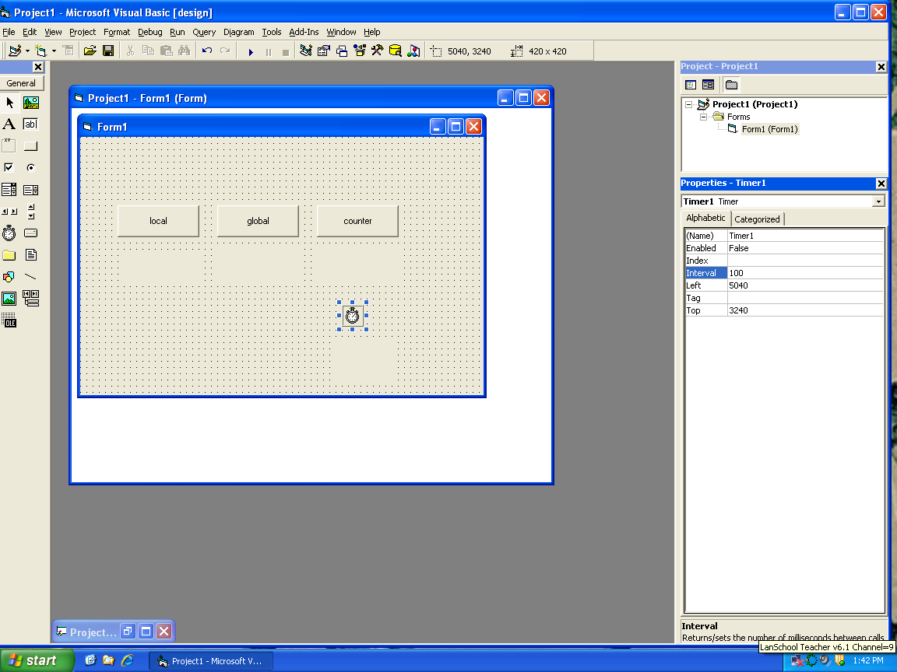

General:

Dim x As Integer

Private Sub cmdcounter_Click()

x = 0

Timer1.Enabled = True

End Sub

Private Sub cmdglobal_Click()

x = x + 1

lblglobal = x

End Sub

Private Sub cmdlocal_Click()

Dim n As Integer

n = n + 1

lbllocal = n

End Sub

Private Sub Form_Load()

x = 0

End Sub

Private Sub Timer1_Timer()

x = x + 1

lblcount = x

Dim c As Integer

c = x Mod 2

If c = 1 Then

lblcolor.BackColor = vbWhite

Else

lblcolor.BackColor = vbBlack

End If

End Sub